Triple Jump Officiating Guidelines
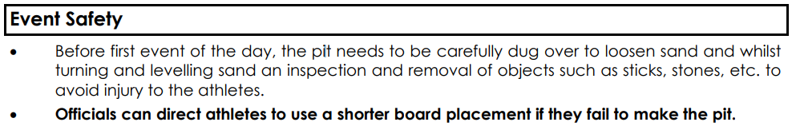
Before each Jump
- Make sure triple jump pit is raked (ie. no foot prints in landing area in sand)
- Runway is clear and all officials / athletes are out of the triple jump pit
- No practice jumps once competition starts
Official roles
- There are 4 key roles for Triple jump (which can be combined depending on number of officials):
  - Recorder: Set athletes up in their jumping order, depending on numbers in group you may need to run 2 groups at once, side by side. Recorder calls out next athlete & records results.
  - Take off area: cleaning board & assess for take-off board foul. Once athlete has jumped, they measure the jump
  - Spike: selecting the landing point of the athlete closest to the take-off area and placing spike with zero end of tape
  - Raking: raking the pit after every jump and ensuring there are no marks in the pit before next athlete starts their run up, don’t rake pit until recorder has completed measurement
Triple Jump rules
- The Triple Jump consists of three distinct skills performed at speed in a continuous action as follows:
- Hop: During the hop, the athlete uses the same foot for take-off and landing.
- Step: Athlete lands on the opposite foot (to that used for the hop).
- Jump: Athlete performs a jump from the "step" foot and lands in the pit.
- Athlete must land in the triple jump pit, record a ‘No Jump’ if any part of the body lands outside of the pit
- Record a ‘no jump’ if any part of the take-off foot goes over the front edge (closest to pit) of the board
- Athletes must exit out the end of the triple jump pit, if they walk back through the landing area before exiting the pit, record a ‘no jump’
- Athletes must take off on one foot, two footed take offs should be recorded as a ‘no jump’
- Spike is placed into landing mark closest to the take off area (ie. Back of foot, or back of hand / body print if athlete fell back)
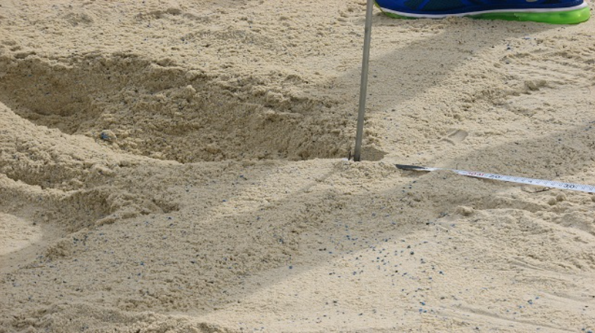
- Zero end of tape measure on the spike and must be dropped to bottom of spike
- measure to the front of the board
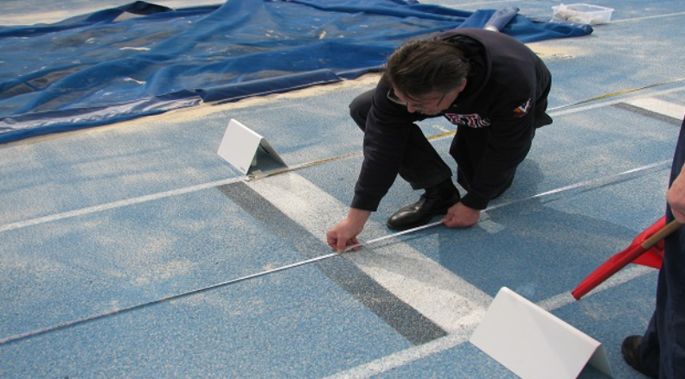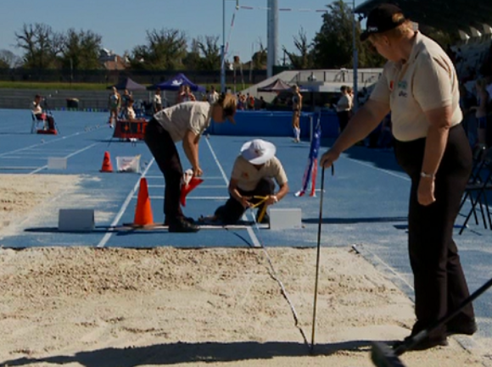
- The tape should be taut & at right angles to the take-off board or its side extensions

