Javelin Officiating Guidelines
Warning: Javelins are dangerous implements
The javelin is a form of spear and as such is a lethal weapon; it can be deflected by gusts of wind.
Event Safety
- The Chief Official should stand alongside the runway in a safe position on the right-hand side of a right-handed thrower and vice-versa
- Apart from the Official on the sector line, everyone should stand behind the athlete and landing sector should be clear.
- The Javelin should be CARRIED back to the runway in a vertical position, tip down, never thrown. Never run back with the Javelin, always walk as the grass can be slippery.
Before each Throw
- Ensure the athlete is using the correct weight
U11B, U12B & U11G-U14G | 400g
U15-U16G | 500g
U13B-U14B | 600g
U15B-U16B | 700g

- Runway should be clean and free of dirt
- Make sure all athletes / officials are in safe locations (
- No practice or use of runway once competition starts
- Make sure the waiting athletes aren’t playing with the Javelins!
Official roles
- There are 4 key roles for Javelin (which can be combined depending on number of officials):
  - Recorder: Set athletes up in their throwing order, Recorder calls out next athlete & records results.
  - Arc Judge: watch for invalid throws, measuring, ensure measuring tape is pulled straight through to the center of circle for measuring (8 meters from Arc).
  - Spike: locating and marking the first point of impact of the metal head of the Javelin and placing spike with zero end of tape
  - Return: returning the Javelin safely to the circle
Javelin rules
- The Javelin must be held at the grip with one hand only. It shall be thrown over the shoulder or upper part of the throwing arm and must never be slung or hurled. Non-orthodox styles are not permitted.
- Until the Javelin has been thrown, an athlete shall not at any time turn completely around, so that their back is towards the throwing arc.
- A trial will be valid only if the metal head strikes the ground before any other part of the Javelin. The Javelin does not have to stick in, but marking is easier if it does. When a Javelin descends at a low angle to the ground it may bounce shortly before producing what looks like a valid landing. This must be carefully watched to see that the metal head impacts first.
- The athlete must not leave the runway until the Javelin has impacted the ground.
- When leaving the runway, the athlete must not leave forward of the throwing arc.
Measuring
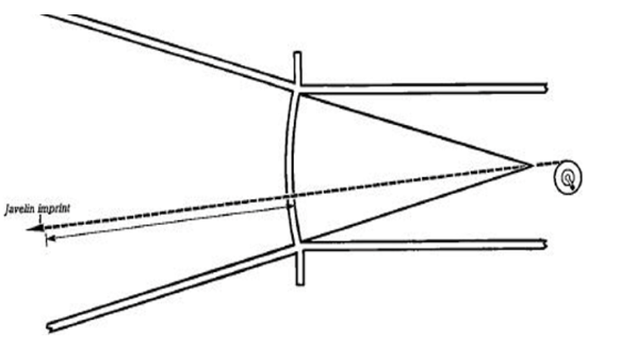
- The measurement of each throw will be made from where the metal head first strikes the ground to the inside edge of the arc along a line from the point of landing to the centre of the circle of which the arc is part.
- The selected point is marked by the spike and the zero end of the tape is held at the spike.
- The tape is drawn tight through the centre of the circle of which the arc is a part (8mts from the arc).
- The distance is measured at the point where the tape crosses the inner edge of the arc.
- The distance is recorded to the nearest centimetre below the distance measured unless the reading is a whole centimetre (eg. 18M 54.4cm = 18.54M)

